Integrated SegFlow, µSIA and UPLC for online sialic acid quantitation of glycoproteins directly from bioreactors

Letha Chemmalil*, Tanmay Kulkarni, Mathura Raman, Priya Singh, Yueming Qian, Chris Chumsae, Kyle McHugh, Zhuangrong Huang, Eric Hodgman, Michael C. Borys, Julia Ding, Gloria Li, Anthony Leon

Affiliation: Bristol Myers Squibb

*Corresponding author
Process Development Analytical Group, GLOBAL PRODUCT DEVELOPMENT & SUPPLY / PRODUCT DEVELOPMENT
Bristol Myers Squibb, 38 Jackson Rd., Devens, MA 01434

Letha Chemmalil Tel: 978-484-6922 email: letha.chemmalil@BMS.com

ABSTRACT
Monitoring and controlling of sialic acid contents in glycoproteins such as erythropoietin (EPO), interferon-γ, Orencia, Enbrel and others are critical to achieve desired therapeutic benefits. The pharmacokinetics (PK) profile of asialoglycoprotein is known to impact protein clearance with its uptake by hepatic asialoglycoprotein receptors (ASGPR) and subsequent physiological clearance. The ASGPR recognizes and binds to glycoproteins with exposed terminal galactose or N-acetyl galactosamine residues to undergo receptor mediated endocytosis. Recent studies have demonstrated that sialylation of O-linked-glycan plays a role in protecting against macrophage galactose lectin (MGL) mediated clearance. In addition to the impact on serum half-life, sialylation can influence other clinical performances including immunogenicity, potency, and cytotoxicity. Therefore, the level of sialic acid is a critical quality attribute (CQA) and has become a regulatory requirement to monitor and regulate sialylation to ensure desired clinical performance. To achieve consistent levels of sialic acid in certain therapeutics, the harvest decision as well as the ionic strength of downstream process buffer composition is dependent upon the sialic acid content. Therefore, utilization of Process Analytical Technology (PAT) tools for generating real-time or near-real-time sialic acid content is a business-critical requirement. The work presented here demonstrating the utility of an integrated system consisting of a micro-sequential Injection Analyzer (µSIA) interfaced with SegFlow and a UPLC to enable near-real-time online sialic acid measurements. The fully automated architecture exemplifies the execution of online sampling, automatic sample preparation and subsequent online UPLC analysis. Carefully orchestrated such framework is in alignment with the requirements of PAT to support QbD-driven continuous bioprocessing.

In the past decades, the biopharmaceutical industry has
witnessed a paradigm shift from productivity maximization
to quality optimization. Cell culture fed-batch processes
yielding a ﬁnal monoclonal antibody (mAb) concentration as
high as 5 g/L have become an established standard in indus-
try.
1
On the other hand, modulation of quality attributes has
signiﬁcantly gained importance, starting from early process
development, and not only for biosimilar rs. The assurance of
constant product quality is a key objective for bi opharmaceu-
tical processes as the efﬁcacy, potency, and safety are
dependent on the structural characteristics of the protein.
2
KEYWORDS
FIA Labs, µSIA, Process Analytical Technology (PAT), Quality by design (QbD), Monoclonal antibody (mAb), Continuous bioprocessing, SegFlow
INTRODUCTION
A major proportion of biotherapeutic drugs are glycoproteins such as erythropoietin (EPO), cytokines, monoclonal antibodies (mAbs), glycosyltransferases, and glycosidases that are contributing to the billions of dollars of worldwide sales (Bertozziet al., 2009). Therapeutic glycoproteins are typically produced in living cells using recombinant DNA (rDNA) technology in which regulation of glycosylation such as sialylation is critical to achieve attributes such as targeted activity, desired pharmacokinetics/pharmacodynamics properties, reduced antigenicity and improved stability. The pharmacokinetics or serum half-life of protein therapeutics is influenced by sialylation to mask the galactose moiety of glycoproteins to bind to the hepatocyte ASGPR, reducing glomeruli clearance (Buettner et al., 2018). Asialoglycoprotein, from which the sialic acid has been removed to expose the galactose residue, is expected to bind to the ASGPR localized on the mammalian hepatocytes. Asialoglycoprotein is thus subjected to its removal from the circulation through receptor mediated endocytosis (Steirer, 2009). Numerous recombinant glycoproteins such as EPO, interferon γ, interferon α, and IgG antibodies have shown that masking the terminal galactose and GlcNAc residues from the hepatocyte ASGPR prevents the endocytosis and extend a prolonged circulatory lifetime (Buettner et al., 2018).

Sialic acid moiety of a glycoprotein therapeutic plays a major role in the fate of the drug’s Pharmacokinetics and pharmacodynamics (PK/PD). Mechanistically, capping of sialic acid blocks the binding of the glycoprotein to the hepatocyte specific asilogycoprotein receptor (ASGPR) and prevents the clearance of IgG from the circulation (Pleass, 2021). Some of the examples of sialylated glycoproteins protecting against ASGPR-mediated hepatic clearance are α-2-macroglobulin, ceruloplasmin, folltropin, α-1-acid glycoprotein-1, hepatoglobin, lutropin, lactoferrin, anti-HER-2 antibody pertuzumab, interferon alpha-2b, hTSH, tFSH, Fc-CTLA-4 and others (Chia, 2023). Glycan engineering to increase the sialic acid content of therapeutic is often deployed to increase the circulatory half-life of therapeutic proteins. During the manufacturing of recombinant glycoprotein, the loss of sialylation occurs due to sialidase activity and should be closely monitored and controlled (Chen et al., 2018). In addition to improving the circulatory half-life, sialylated glycans impair complement-dependent cytotoxicity. Sialylation of the Fc domains of IgG also helps to improve solubility, anti-inﬂammatory activity, and thermal stability (Pleass, 2021). A role of sialylation of O-linked-glycan in protecting against clearance via macrophage galactose lectin (MGL) has been proposed recently (Ward, 2022). With the loss of sialic acid from O-glycan results in fast clearance of the glycoprotein from the circulation.
In most cases, sialylation must be optimized to ensure its prolonged circulatory half-life in serum. For example, natural and recombinant forms of erythropoietin (rEPO) for the treatment of anemia in chronic kidney disease carries three sialylated N-glycans and one sialylated O-glycan. The rEPO produced using rDNA technology is highly glycosylated, and has been altered to increase its half-life in serum for reducing the frequency of the administration. Reduced half-life of protein therapeutics in the absence of sialic acid is governed by the clearance of galactose exposed asialoglycoproteins from the circulation via ASGPR- mediated endocytosis (Chemmalil, 2014). Sialic acids are negatively charged monosaccharides presented as the terminal residues on glycans. The two most common sialic acids in biopharmaceuticals are N-acetylneuraminic acid (Neu5Ac or NANA) and N-glycolylneuraminic acid (Neu5Gc or NGNA). While NANA is found in both human and non-human cells, NGNA is synthesized by all mammalian cells except human cells. The presence of terminal NANA has been shown to impact various key properties of glycoproteins, including circulatory half-life, solubility, and thermal stability (Lewis et al., 2016). Engineered EPO with a hyper-sialylation has been shown to exhibit better pharmacokinetic properties, especially having a longer half-life in the bloodstream (Varki, A. & Schauer R, 2009). The only one oxygen atom difference between NANA and its homologue NGNA is sufficient for the NGNA to be highly immunogenic in human. Hence, maintaining a desired level of NANA while demonstrating the absence of NGNA in protein therapeutics is important for safety and better pharmacokinetic properties.
To maintain a desired level of sialic acid in glycoprotein therapeutics, engineering design and control of sialylation levels of biopharmaceuticals are important (Varki, A. & Schauer R, 2009). If the sialic acid content of therapeutics in harvest culture does not meet the established sialic acid specification, the batch might have to be discarded, unless an enrichment of sialic acid content can be performed during the downstream unit operations (Dahotre, 2022). In addition to the incorporation of engineering design, companies have been attempting to execute harvest decisions based on the sialic acid content to achieve a desired levels of sialic acid in the harvested material. To execute the harvest decision based on sialic acid content, a real time or near-real time sialic acid data generation is essential. Similar process controls also need to be in place during downstream purification steps. For example, the conductivity of the wash buffer needs adjustment in accordance with the sialic acid content of the loading material to maintain a desired ration of sialic acid to protein. To decide on the ionic strength of wash buffer, assessment of sialic acid at the termination of the preceding step of the unit operation is a pre-requisite. Therefore, obtaining sialic acid results with a fast turn-around-time is imminent. For the timely process execution based on sialic acid content, rapid generation of sialic acid results as well as a synchronization between the PAT system and the process equipment to make the informed decision is important. Monitoring and controlling of NANA and NGNA at all stages of the product life cycle are critical to ensure that PK/PD, safety, and efficacy of the protein therapeutics are in alignment.
Given the compelling need for maintaining CQAs such as sialic acid at a desired level, implementation of modern analytical tools such as PAT is inevitable. Allison et al. (2015) pointed out that the deployment of PAT tools not only can improve process understanding, but also can provide an opportunity to control the process to maintain a consistent product quality. To support QbD driven continuous bioprocessing, development of PAT tools with reduced analysis time is essential for real-time or near-real-time data generation such that appropriate control strategies can be deployed to maintain the process in a steady sate. Deployment of QbD paradigm to modernize the pharmaceutical/biopharmaceutical industry requires inline, online, or at-line tools to align with the strategy to monitor real-time or near-real-time product quality to control the process to achieve a desired final product quality.
Biopharmaceutical companies are transitioning to adopt QbD paradigm in lieu of quality-by-testing strategy to increase product and process understanding to comply with the FDA’s guidance (Ferreira & Tobyn, 2015). Continuous bioprocessing can increase production flexibility, reduce facility footprints, increase productivity, and reduce the overall production cost. Implementation of continuous bioprocessing is relied upon the establishment of PAT tools for real-time or near real-time monitoring of product qualities to facilitate timely control of the process. The shift in paradigm towards the implementation of QbD strategy in leu of the traditional quality-by-testing practice is intended to improve product quality, which has been the focus of the biopharmaceutical sector to achieve high productivity with >10 g/L mAb titers (Gyorgypal & Chundawat, 2022). To enable QbD platform, FDA has been recommending drug manufacturers to embrace and deploy PAT tools for the timely measurements and control of CQAs to ensure desired final product quality (Raj & Gupta, 2016).
Regulatory agencies are in favor of QbD-enabled continuous bioprocessing to improve product quality and to maintain batch-to-batch reproducibility (Kornecki et al., 2019). FDA Chief Dr. Woodcock has stated that continuous bioprocessing can dramatically shorten the time that it takes to scale up manufacturing for the newly approved drugs (Alper & Rapporteur, 2019). For the past several years, the biopharmaceutical companies have been actively engaged in transitioning from the current mode of batch processing to adapt a highly efficient and agile continuous bioprocessing with the adaptation of QbD platform to develop robust processes to deliver safe and efficacious drugs. To support continuous bioprocessing, PAT tools for real-time or near-real-time monitoring and control of CQAs such as sialic acid is inevitable. Regulatory agencies are urging the use of advanced PAT tools to establish the design spaces for enhancing process understanding with the option to implement timely process control to manufacture high-quality biologic-drugs (Gyorgypal & Chundawat, 2022).
Shifting from batch process to QbD enabled continuous bioprocessing with the deployment of PAT tools can provide an opportunity to enhance the process and product understanding as well as to facilitate cost-effective manufacturing (Mascia & Trout, 2015). To keep up with the increased demand for achieving process robustness and process understanding during bioprocessing, the regulatory initiative to incorporate the PAT tools serves as an ideal platform to enhance product quality via increased process understanding and timely control (Kornecki and Strube, 2018; Jenzsch et al., 2018). With the flexibility to control the process, QbD driven continuous bioprocessing offers efficient delivery of high-quality products at a reduced cost (Subramanian, 2014). Some of the setbacks in the advancements of QbD-enabled continuous bioprocessing are attributed to the lack of PAT tools available to monitor and control the manufacuring processes (Vargas et al., 2018).
The shift from quality-by-testing to the new paradigm of quality-by-design approach of the next generation continuous bioprocessing requires the deployment of PAT tools. With the utilization of PAT, enhanced process-understanding is feasible such that implementation of control strategies can be deployed to ensure consistent product quality. As Rathore & Winkler (2009) stated, implementation of PAT is critical for developing safe and efficacious therapeutics. The modernization of current drug manufacturing has been inspirational to the companies to leverage integrated PAT tools instead of the current practice of product quality testing at the end of the process (Bayer, 2014). This is in alignment with the FDA-recommended QbD-based drug development and manufacturing to improve product quality (Yu et al., 2014).
With the ability to monitor in-process CQAs rather than testing at the end of each batch, regulatory agencies have been encouraging companies to take advantage of QbD and PAT implementation for new process approvals (Zobel-Roos et al., 2019). FDA has been encouraging companies to develop and deploy technologies for real-time monitoring and controlling of product qualities. Deployment of inline, online, and at-line measurements provide the operational flexibility to intervene if the system deviates from the established design space, providing an opportunity to maintain the process in a state of control. FDA has been encouraging biopharmaceutical companies to embrace novel technologies, providing inspiration for building digital platforms to establish process capabilities with automatic feedback control. Process monitoring using online analytical techniques will lead to efficient process development and control (Alper & Rapporteur, 2019). For example, monitoring glycans at real-time or near-real time can help to understand the influence of process parameters on specific glycosylation, which can then enable the deployment of an effective control strategy to achieve desired glycosylation.
Regulatory agencies are encouraging drug manufacturers to embrace QbD and PAT driven platforms for drug development (Zobel-Roos et al., 2019). Implementation of integrated continuous bioprocessing not only can improve the quality of therapeutics, but also can reduce the capital expenditure. FDA has been taking initiatives to promote the implementation of QbD driven continuous bioprocessing and the adaptation of synergetic PAT technologies (Alper & Rapporteur, 2019). Benefits of continuous bioprocessing include miniaturization of facility footprints and increased product titer, leading to a higher productivity at a reduced cost (Croughan et al., 2014). Given the many benefits of continuous bioprocessing, implementation of PAT tools to establish an integrated continuous bioprocessing is integral to keep the process in a state of control (Alper & Rapporteur). Implementation of QbD-enabled technologies such as PAT is essential for safe and effective drug development and manufacturing (Winkler, 2009). Despite the numerous progresses that have been made, the field of PAT is still undergoing continued evolution in the context of methodological and technological innovations (Croughan et al., 2015). In response to the disclosure of FDA’s vision at the AAPS annual meeting on the topic of efficient and flexible continuous manufacturing process, biopharmaceutical companies are anxious to adapt the emerging PAT platform (Chatterjee, 2012).
PAT tool development for biophrmacutical applications is more challenging than develping PAT tools for pharmacetical applications. In addition to the significant size difference, biopharmacutical drugs produced in the living cells consist of complex matrix components, interfering with the direct analysis. Ideally, if the chromatographic techniques utilized for offline testing can be extended to the online testing, comparable data can be generated with a faster turn around time (Chemmalil et al., 2022). For example, UPLC system interfaced with a process sample manager is suitable for online monitoring of upstream titer and downstream product quality utilizing the legacy offline method in an online setting (Chemmalil eta al., 2020). Similarly, 2D-LC system interfaced with SegFlow autosampler is suitable for online product quality measurements of upstream samples leveraging the 1st dimension of 2D-LC for protein A purification and 2nd dimension for product quality assessments (Chemmalil et al., 2021a). Online quantitation of amino acid contents during upstream cell culture process is accomplished using the Agilent UPLC system interfaced with SegFlow, leveraging the system’s unique feature of in-column derivatization capability (Chemmalil, 2021b).
Unlike other product quality assays, sialic acid quantitation method along with some of the convoluted analytical methods such as peptide mapping, N-linked glycan analysis, and multi-attribute methods require complex sample preparation. Such complexity has posed a setback in the biopharmaceutical industry to develop PAT tools for timely measurements of certain CQAs such as sialic acid. Since sialic acid has a dramatic effect on pharmacokinetics of biotherapeutics to reduce the clearance from the circulation, it is critical to regulate sialylation during the production of certain glycoproteins (Higel et al, 2019). Health authorities have recognized the significance of reducing the batch-to-batch variability and maintaining a consistent product quality throughout the manufacturing process. To enhance consistency, biotherapeutic manufacturers have made enormous effort to ensure that approved drugs fall within the defined specifications (Bertozziet al., 2009). The evolution towards the QbD-driven continuous bioprocessing is designed to produce high quality drugs with consistent product quality.
Maintaining consistent levels of sialylation for glycoprotein therapeutics is a regulatory expectation. Various methods have been established for the quantification of sialic acids including HPLC and microtiter plate based colorimetric/fluorometric assays as well as mass spectrometry (MS) based methods. HPLC and MS are widely used techniques for routine and non-routine applications, respectively. Although MS based multi-attribute methods are deployed for sialic acid quantitation exclusively from N-linked glycan data, the validity of these results is often questionable because the sialic acid derived from O-glycans are not accounted for the estimation. For HPLC analysis, the free sialic acid is often derivatized with chromophores or fluorophores to achieve stabilization and enhancement of detection sensitivity. The derivatizing reagent, 1,2-diamino-4,5-methylenedioxybenzene (DMB) is commonly used fluorophore for the quantitation of total sialic acid during HPLC analysis. HPLC with UV detection of non-derivatized NANA and NGNA is an alternative approach, but encounters enormous variability associated with the refractive index interference at low UV wavelength detection.
For the quantitation of non-derivatized sialic acid, LC/MS is a viable option, but may not be suitable for a quality control lab for release testing. HPLC interfaced with NQAD detector has been demonstrated to be a viable label-free option (Chemmalil et al, 2014). HPLC or UPLC interfaced with other universal detectors such as charge aerosol detector (CAD), Evaporative Light Scattering Detector (ELSD) or Refractive Index (RI) detector can be employed with careful evaluation. Over the past decade, several bio-affinity-based approaches for the direct detection of sialic acids and sialylglycans have been developed, including lectins, antibodies, and recombinant sialic acid-binding proteins (Zhou et al., 2020). Lectins are sugar-binding proteins that can specifically recognize glycans on glycoconjugates. Sambucus nigra lectin (SNA) and Maackia amurensis lectin (MAL) are commonly used for preferentially binding to sialic acid (Zhou et al., 2020).
The motivation behind the study presented in this paper is to explore the use of sequntial µ-injection analyzer (µSIA) system from FIA Labs for the pursuit of online sialic acid quantitation. This highly versatile µSIA system, controlled by python scripting, is suitable for online sialic acid quantitation. Current practice of offline sialic acid quantitation at the end of the cell culture process exhibits a bias due to the lag time associated with the lengthy analysis time. Similar bias occurs during downstream purification step at which the conductivity of the wash buffer is determined based on the sialic acid content of the feed material. With the use of µSIA system as a sample preparation platform coupled with the SegFlow sampling device and an integrated online UPLC system, a near-real-time quantitation of sialic acid can be achieved. The integrated system facilitates online monitoring of sialic acid contentment and provides the opportunity to maintain a consistent mole/mole sialic acid to protein ratio from batch-to-batch.

2. Materials and Methods

Reagents
Reagents, Columns and Systems
C18 column (Infinity Lab Poroshell 120 EC-C18 column (2.1 x 75 mm, 2.7 µm) was purchased from Agilent. Ascentis Express 90A, RP Amide columns (10cm x 2.1mm, 2.7um; 10cm x 2.1mm, 2 um) were purchased from Sigma Aldrich. Sialic acid kit, containing DMB, phosphoric acid, NANA, NGNA and fetuin, was purchased from Agilent. HPLC-grade Water and acetonitrile for the mobile phases were purchased from Fisher Scientific (Hampton, NH) and formic acid was purchased from Sigma Aldrich (St. Louis, MO). All chromatographic separations were performed on Waters ACQUITY Classic UPLC system composed of the following modules and control software: Binary Solvent Manager, Sample Manager, Column Manager (CM-A), UV/Vis/fluorescence detector and Empower-3 Software/Windows 10 PC. Note: The µSIA cannot work with sample managers with flowthrough needle (FTN) as the injection valve on an FTN injector is lacking the necessary ports to allow a sample to be fed from an external source. The SegFlow autosampler consists of SegFlow 4800, SegMod, SampleMod 300, and associated accessories such as FISP probe, and cleaning liquid containers. The sample processing system consists of µSIA, SMA-A micro-volume flow cell, DH-2000 Ocean Insight deuterium lamp spectrophotometer and a protein A column.

PAT Instrument modules
The integrated SegFlow-µSIA-UPLC PAT system is a fully automated platform, configured to achieve online sampling followed by titer measurement, inline sample preparation and subsequent online UPLC analysis. Flownamics’ SegFlow 4800 online sampling system is interfaced with the µSIA device to draw cell-free sterile samples from the bioreactors using 310 nm F-series FISP probe with 0.2mm pore size ceramic membrane (Flownamics Inc., Madison, WI) to deliver samples to the µSIA through SegMod-SampleMod. Such on-line sampling technology allows rapid and accurate sampling from up to eight bioreactors to deliver samples up to 4 analyzers. This way, the existing off-line and at-line analyses are seamlessly integrated into an on-line PAT tool through FIAlab’s SIAsoft software. The SIAsoft simultaneously acquires and exports all integrated data to any OPC-enabled SCADA for enhanced process monitoring and control. Custom scripts were written to establish communication between the SegFlow autosampler and the µSIA such that sample withdrawal and subsequent workflow can be scheduled and coordinated with minimal human intervention.
Custom scripts were written in Python programming language to streamline the end-to-end process with a fully automated configuration. The 1st step of the workflow begins with acquiring cell-free culture samples from the bioreactor using SegFlow, followed by loading of a fixed volume of cell-free sample for titer determination to a Protein A cartridge with UV detection of the eluent at 280 nm. The 2nd step is the repetition of the 1st step with loading of a fixed mass of protein onto a protein A column at neutral pH, and subsequently elute the protein using low pH buffer. In the 3rd step, the eluted protein is subjected to acid hydrolysis to release the sialic acid followed by DMB labelling. DMB labelled sialic acid is then pushed into the UPLC for the separation and quantitation of NANA and NGNA. Scheduling of sample withdrawal and sample analysis can be customized according to the user preference for which the open-source features enable feedback control via a distributed control system (DCS).
The µSIA system interfaced with SegFlow and UPLC has served as the online PAT tool for measuring sialic acid concentrations of proteins from a 5L bioreactor (Applikon, Foster City, CA) to maintain a desired levels of sialic acid across all batches. The Lab-On-Valve µSIA system consists of a fully integrated 10-position selector valve, enabling high-reproducibility of physical workflow including sample preparation, mixing, injection, and optical monitoring in an automated fashion with all the chemistry taking place within the valve manifold, eliminating the need for additional tubing and connectors. As depicted in Figure 1, each of the Lab-On-Valve's ports is assigned a specific function such as flow through, reagent aspiration, composite sample handling and waste elimination. The ports are interconnected by microchannels and a built-in multipurpose flow cell that is interfaced with optical fiber probes for spectral analysis. This fully automated system replaces otherwise laborious manual sample preparations.
The system is leveraging computer-controlled multi-position valve and peristaltic pump and operated synchronously with these multi-position valves. In µSIA, samples and reagents are aspirated into the holding coil by operating the pump in a reverse mode such that the carrier is returned to the reservoir. Restoration of forward pumping is synchronized with the opening of the valve port leading to the detector. The flow reversal leading to a mixing of the stack of sample and reagent zones to form a product zone which is transported to the detector. The pump tubing comes into contact only with the carrier while the sample and reagent being aspirated into the holding coil. Coupled with two ten-port valve manifolds, two nine-port-syringe pumps and computer control, the µSIA can be fully automated to incorporate the wet lab procedures with precise control of assay parameters including sample dilution, sample addition, mixing, etc. The µSIA consists of reaction coil, high-precision bi-directional syringe pumps (SP1 and SP2) and a peristaltic pump. The peristaltic pump, furnished with PTEE-tubing, is utilized for filling the conduit from the external sample reservoir if SegFlow is not being used for sampling.
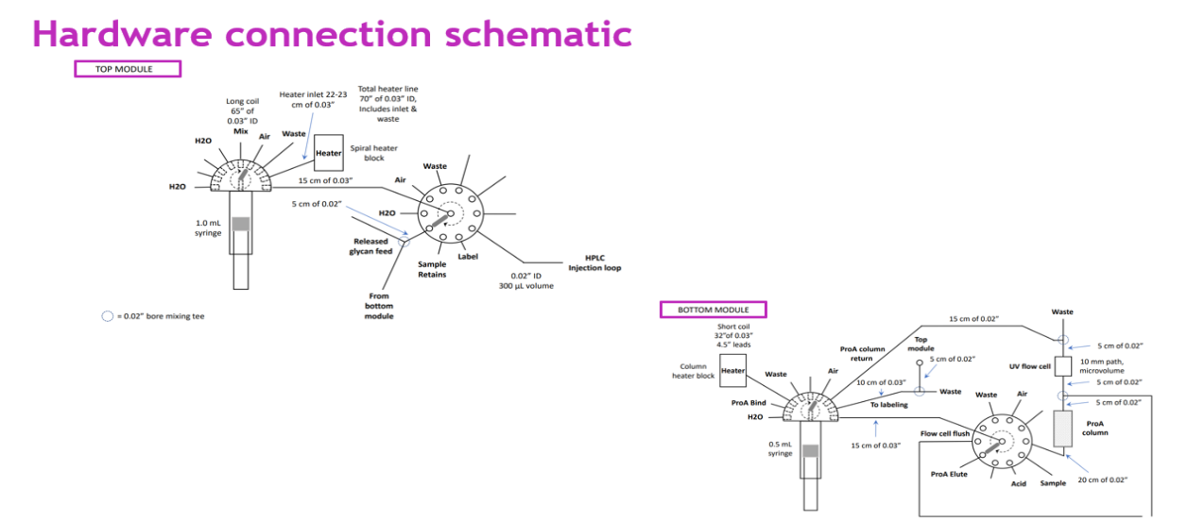
Figure 1: Schematic of µSIA system architecture.
Experimental

2.1 Online sampling, inline Protein A purification, Sialic acid release, DMB derivatization
For online sampling from bioreactors, the µSIA system from FIA Lab is interfaced with SegFlow autosampler to draw samples from the bioreactors and subsequently delivering the sample to the designated port of the µSIA module. The received sample is then loaded on to a Protein A column and eluted off in fixed volume of elution buffer to obtain protein titer of the bioreactor sample. The eluted protein that passes through the UV detector is sent to the waste line during the 1st cycle. Based on the titer information generated on the 1st cycle, predetermined quantity of protein is loaded on to the Protein A column during the 2nd cycle, subjected to inline Protein A purification to remove process impurities from the protein of interest. The purified protein is then subjected to acid hydrolysis to release the sialic acid and subsequently labeled with DMB. The DMB-labeled sialic acid is then injected into the UPLC to separate NANA from NGNA and other components of the reaction mixture. Picomoles of NANA and NGNA are determined by interpolating the peak responses from respective standard curves constructed using DMB-labelled NANA and NGNA standards. From the calculated picomoles of NANA and NGNA, mole/mole ratio of sialic acid to protein is determined based on the titer value generated during the initial protein A step described above.

2.2 Initial evaluation of chromatographic conditions to separate NANA and NGNA

Ascentis Express 90A, RP-amide columns (10cm x 2.1mm, 2.7um) was initially evaluated under an isocratic mode using the mobile phase 0.1% FA/10% acetonitrile for10 minutes at a flow rate of 0.2 ml/min. Column temperature was maintained at 30˚C. An experimental run was performed with NANA and NGNA standard mixture at 1:1 ratio.

2.3 Optimized chromatographic conditions to separate NANA from NGNA
To separate labelled sialic acids (NANA & NGNA) from multiple components of the reaction mixture and resolve NANA from NGNA, columns with different chemistries from different manufacturers were evaluated. The list of columns subjected to the evaluations include columns of different chemistries including Agilent C18 column (Infinity Lab Poroshell 120 EC-C18, 2.1 x 75 mm, 2.7 µm, narrow bore LC column), Supelco C-18 column and Waters X-bridge column and Sigma/Aldrich Ascentis Express RP-Amide column (2.7 μ, 10 cm X 2.1 mm). All columns were evaluated under different gradients and column temperatures.

2.4 Acid hydrolysis vs. Sialidase Digestion
For executing automatic workflow using µSIA, protein A purified sample collected in the collection coil is subjected to de-sialylation and DMB labelling. For releasing sialic acid from glycoprotein, acid hydrolysis and sialidase digestion were evaluated. For releasing sialic acid using sialidase using Agilent kit, 18 µl of sample + 4 µl of Sialidase A + 8 µl of reaction buffer were incubated at 37˚C for 30 minutes followed by 3 hours of labeling with DMB. For acid hydrolysis, 90 µl of sample was treated is with 10 µl of phosphoric acid and incubated at 80˚C for 2 hours followed by 3 hours of DMB labelling. After labeling, water was added to bring the total volume to 1 mL and collected the entire mixture in a collection vial. The HPLC delivery line is flushed with water and then primed with as much labelled sample is available. Then a part of the sample is delivered into the retains vial if needed to repeat the analysis. The syringe pump empties all the remaining sample to the HPLC delivery line such that the front of the sample zone primes the line and continues to the waste while what is left in the LC sample loop is preserved for injecting into the UPLC system under the online analysis mode.

2.5 Attempt to reduce acid hydrolysis time comparable to sialidase digestion of 30-minutes.

Comparability data of acid hydrolysis vs. sialidase digestion indicated that sialic acid release was higher with acid hydrolysis, despite the inefficiency of needing an increased digestion time. To reduce the 2-hour acid hydrolysis time to make it compatible to the 30-minute sialidase digestion-time, an experiment was conducted to evaluate 30-minute acid hydrolysis vs. 2-hours at 37˚C. Analysis was conducted under the offline mode.

2.6 Optimization of DMB derivatization time
To optimize DMB derivatization, a time course study was conducted at 2, 3 and 4 hours at 50˚C. For DMB labeling, 30 µl of sample and 10 µl of labelling reagent were vortex-mixed and incubated at 50˚C for 3 hrs. After incubation, 160 µL water was added and transferred it to the HPLC vials for offline testing.

2.7 One factor at a time (OFAT) analysis to optimize sialic acid release derivatization.
To optimize the de-sialylation and DMB-derivatization, a screening of OFAT (one factor at a time) statistical analysis was conducted. OFAT was chosen over DOE (Design of Experiment) to identify the preferred course of action for sialic acid release (sialidase digestion or acid hydrolysis) and DMB derivatization. A time course study was incorporated to the DOE design to select the optimal combination of de-sialylation and DMB digestion conditions.

2.8 Fully integrated SegFlow/µSIA/UPLC Platform
With the help of appropriate information management system, synchronization between µSIA with UPLC can be fully established with or without the integration of distributed control system. As soon as the method run is executed from µSIA, the software immediately sends a command to execute an Inject Hold state on the UPLC. Right after that, when starting the established UPLC sequence, LC injection valve is switched to the Load position so that the LC can accept the sample from µSIA. Although the sequence is formally initiated, the Inject Hold status of the FIAlab method prevents the system from proceeding to the injection at this point. When the µSIA has processed the sample and filled the LC injection loop, the Inject Hold command will be released, and the LC will now proceed with the first injection in the sequence. The fully integrated architecture consists of SegFlow for online sampling, µSIA for automated sample preparation and UPLC for sialic acid profiling. This integrated system facilitates the execution of a fully automated platform for timely measurements of sialic acid directly from upstream bioreactors and downstream AKTA purification systems.

3. RESULTS:

3.1 Inline Protein A purification

During the protein A purification step, an issue was encountered with the appearance of an interfering shoulder on the chromatogram, derived from the stroke of the syringe pump during the delivery of the elution buffer. This artifact was impacting the accurate titer determination. To overcome this issue, hardware and python scripts were modified to deliver the elution buffer from 2 syringes: one from the top module and the other from bottom module of the µSIA system. With this modification, the artifact issue was resolved, and a fully automated system configuration was enabled with the advantage of generating online titer values required for reporting mole-to-mole sialic acid to protein ratio.

3.2 Initial evaluation of chromatographic conditions to separate NANA and NGNA

Initially, we encountered an issue with the absence of synchronization between µSIA and the UPLC injector to enable the execution of injection upon receiving the inject-command from the µSIA. Neither changing the python script nor modifying the instrument settings had enabled the synchronization of the UPLC injection in response to receiving the command from μSIA. To overcome this challenge, an external valve was mounted onto the UPLC system. The external valve acts as a switch between the $µ$SIA and the UPLC system to accept the command from the event table of the instrument method. With this hardware modification, the communication between µSIA and UPLC has been fully enabled. Figure 2 exemplifies the progress made on the synchronization, exhibiting a representative online chromatogram of NANA and NGNA, generated using Ascentis RP-amide column with the use of mobile phase 0.1% FA/10% acetonitrile under an isocratic run at 30˚C for 10 minutes at a flow rate of 0.2 ml/minutes.

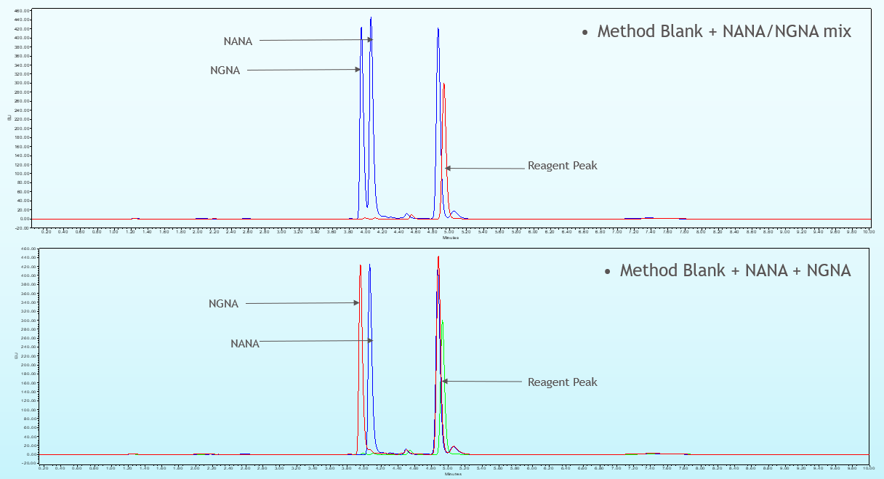

Figure 2: Chromatographic profile of NANA & NGNA under isocratic run

3.3 Optimized chromatographic conditions to further separate NANA from NGNA
Despite the encouraging outcome from the evaluation of Ascentis RP-amide column, further optimization was needed to improve the resolution between NANA and NGNA. We evaluated columns from other manufacturers against Ascentis RP-amide column to make the best possible selection. As a mixed mode column, Ascentis RP-amide column outperformed other columns and hence the decision was to move forward with Ascentis RP-amide column for further optimization. To achieve better separation between NANA and NGNA, a gradient elution instead of isocratic run was carried out at 0.2 ml/minute flowrate by maintaining the column temperature at 30˚C. Mobile phases used for the gradient run were 0.1% formic acid in water as mobile phase A and 0.1% formic acid in acetonitrile as mobile phases B. Initial gradient of 6% was maintained for 1 minute followed by a ramp up to 20% for 3 minutes and a subsequent 2-minutes isocratic run. The eluate is detected with a fluorescence detector (Excitation and Emission wavelengths are 373 448nms, respectively). As illustrated in Figure 3, the chromatogram obtained from the finalized condition has exhibited baseline separated NANA and NGNA.

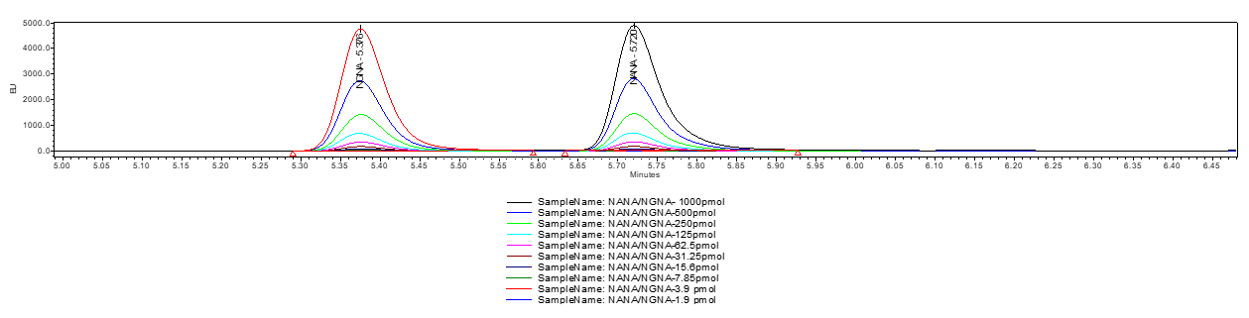

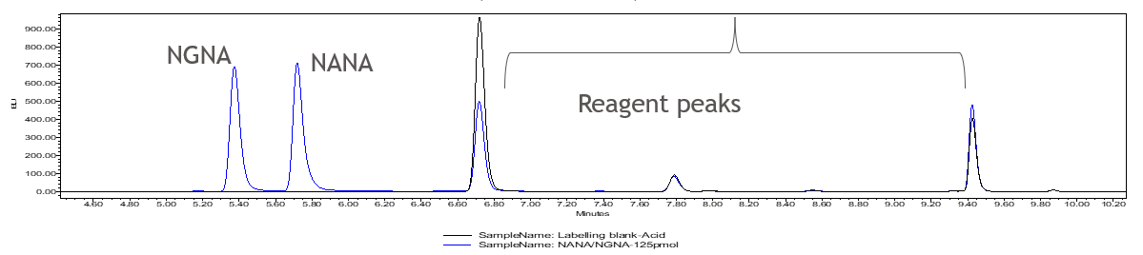

Figure 3: Chromatographic profile of NANA & NGNA under gradient run

3.4 Acid hydrolysis vs. Sialidase Digestion

To execute fully automated acid hydrolysis, a hardware reconfiguration was required. Although the PNGAse-F digestion script established by FIA labs for N-glycan release can be adapted for sialidase digestion to release sialic acid, the same script was not applicable for acid hydrolysis. While the PNGAse-F and sialidase digestions can be carried out within the column in conjunction with protein A purification, the protein A purification and acid hydrolysis needed to be decoupled for acid hydrolysis because the low pH environment of acid hydrolysis is incompatible with the binding of the protein to the protein A column. While PNGase-F and sialidase digestion is taking place in the presence of bound protein on the column at 37˚C, the same approach cannot be adapted for acid hydrolysis due to the negative impact on binding and column integrity under the highly acidic condition. Decoupling of protein A purification and hydrolysis had presented another challenge of not having a heater to perform the hydrolysis at 50$˚C$for 2 hours. To overcome this challenge, a hardware reconfiguration was enabled such that the column heater from protein A compartment was relocated to perform hydrolysis at a higher temperature as it is acceptable to do protein A purification at ambient temperature. Evaluation results of acid hydrolysis vs. sialidase digestion suggested that acid hydrolysis is more efficient than sialidase digestion. As shown in Figure 4, the black line is from the 30-minutes sialidase digestion and 3 hours labeling of protein-X and blue line is 2 hours acid hydrolysis and 3 hours labelling of the same protein.

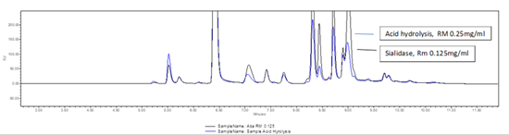

Figure 4: Overlaid chromatograms resulted from acid hydrolysis vs. sialidase digestion

3.5 Attempt to reduce acid hydrolysis to 30-minutes (same as sialidase digestion)

Although acid hydrolysis outperformed sialidase digestion, the time for acid hydrolysis is significantly longer (2 hours) than sialidase digestion (30 minutes). An attempt made to reduce the hydrolysis time to 30 minutes to make it comparable to sialidase digestion time was not successful. As shown in Figure 5, 30-minute hydrolysis is not as effective as 2-hours hydrolysis. The intensities of NANA and NGNA peaks are significantly lower for 30-minute hydrolysis.

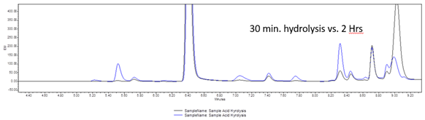

Figure 5: Comparison of 30minutes hydrolysis vs. 2 hours hydrolysis

3.6 Optimization of DMB derivatization time

A time course study conducted to optimize DMB derivatization has suggested that maximum derivatization is achieved at 3 hours. As depicted in Figure 6, the peak intensity is relatively higher for 3-hour labeling in comparison to 2 and 4 hours labeling.

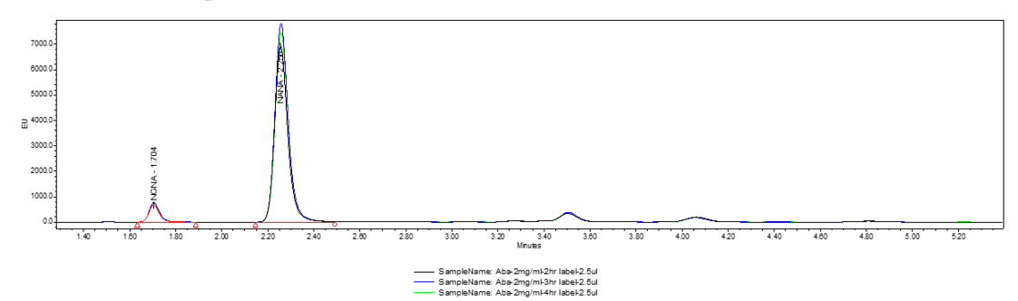

Figure 6: Comparison of 2 hrs., 3hrs. and 4 hrs. of DMB derivatization time

3.7 One factor at a time (OFAT) analysis to optimize sialic acid release and derivatization
OFAT experimental results generated with sialidase digestion, acid hydrolysis and DMB labeling at different time courses have suggested that 2-hrs acid hydrolysis in conjunction with 3-hrs DMB labeling is the optimal combination for the best performance. Also indicated that RP-Amide column provided better recovery of NANA. OFAT results are presented in Table 1.
Digestion Conditions | RP Amide column |  | C18 column
 | NGNA (mol/mol) | NANA (mol/mol) | NGNA (mol/mol) | NANA (mol/mol)
2-hr sialidase digestion  3-hr labelling | 0.5 | 7.9 | 0.4 | 6.9
1-hr acid digestion  3-hr labelling | 0.5 | 7.4 | 0.4 | 6.4
2-hr acid digestion  2-hr labelling | 0.6 | 8.7 | 0.5 | 7.6
2-hr acid digestion  2-hr labelling | 0.5 | 7.8 | 0.5 | 7.0
2-hr acid digestion  3-hr labelling | 0.6 | 9.0 | 0.5 | 7.9
2-hr acid digestion  4-hr labelling | 0.6 | 8.5 | 0.5 | 7.5

Table 1: Results of one factor at a time (OFAT) analysis

3.8 Fully integrated SegFlow/µSIA/UPLC Platform
The schematic shown in Figure 7 has been accepted as the established workflow for moving forward. A representative chromatogram of DMB labeled sialic acid released from protein-X using the optimized workflow is shown in Figure 8. As shown in Table 2 and Figure 9, the offline data generated using the conventional approach and the online data generated using the integrated SegFlow/µSIA/UPLC platform are quite comparable with minor differences that are falling within the inherent variability of the UPLC-based sialic acid method.
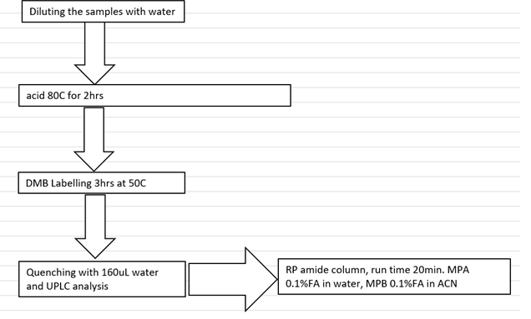
Figure 7: Schematic of Sample prep workflow for sialic acid release and derivatization
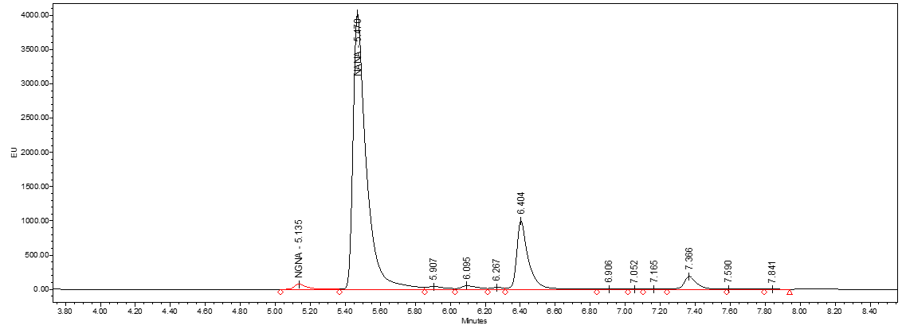
Figure 8: A representative chromatogram of Protein-X Reference material
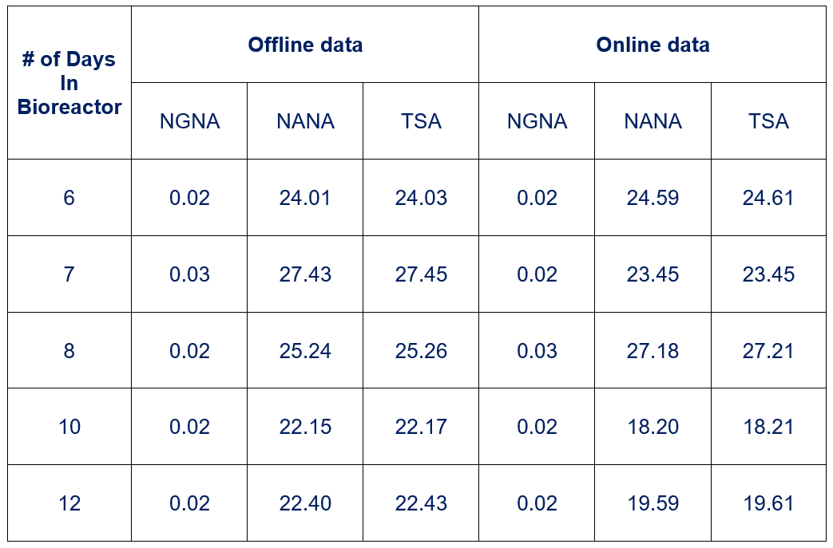
Table 2: Comparability of offline vs. online sialic acid data of bioreactor samples

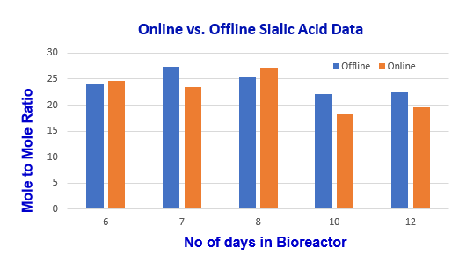
Figure 9: Comparability of offline vs. online sialic acid data illustrated in bar graph.

4. Discussion

Sialic acid capping at the nonreducing terminals of N- and O-glycans can have an impact on biological action in mediating efficacy, immunogenicity, pharmacokinetics, and pharmacodynamics of therapeutic glycoproteins. Depending upon the nature of the molecule, the terminal sialic acid may play assorted roles in impacting the rate of clearance, inflammatory response, and antibody-dependent cellular cytotoxicity (ADCC). Among the NANA and NGNA isotypes found in biotherapeutics, NGNA can potentially be immunogenic to human as this isoform is not synthesized by humans. For this reason, monitoring and controlling the levels of NGNA present in therapeutic glycoproteins from a safety perspective is as critical as monitoring and controlling NANA for achieving desired PK. To maintain the levels of NANA and NGNA at a desired specification, the time of upstream harvest decision is often determined based on the levels of sialic acid derivatives present. Similarly, there is an opportunity to control sialic acid contents during downstream polishing step by adjusting the ionic strength of the wash buffer.
To monitor the levels of sialic acid within the specified range, the current practice of submitting samples for offline sialic acid testing with prolonged waiting period is not only inefficient, but also has a concern about the validity of the timepoint. Given the lengthy lag-time, there is a risk of missing the optimal harvest time-point at which the sialic acid is at its peak. Once the peak-level of sialic acid is attained, a sudden decline in sialic acid content is expected due to the enhanced sialidase activity associated with the increased cell apoptosis. Therefore, a need for real-time or near-real-time measurement of sialic acid is inevitable. Attempts made previously to utilize spectroscopic techniques to develop predictive modeling to achieve real-time data had only limited success. To maintain accurate sialic acid results comparable to the currently deployed UPLC method, we decided to automate the workflow including the bioreactor sample withdrawal, protein A purification, acid hydrolysis, DMB labeling and automatic delivery of labeled sialic acid to the UPLC.
To establish an automated integrated workflow, SegFlow autosampler was interfaced with µSIA system at the front end and a UPLC system at the back end. The samples drawn from the bioreactors are deposited in a sampling tube located in the µSIA module. Subsequent injection of the sample from the vial to the protein A cartridge allowing the auto-purification in conjunction with providing the titer results. Protein A purified samples are then subjected to acid hydrolysis and DMB derivatization prior to the injection into the UPLC system, equipped with RP-amide column and fluorescence detector. NANA and NGNA that are separated from other components as well as from each other are then quantitated against their respective standard curves. The quantitation values of mole/mg are then converted to mole/mole ratios.
As illustrated in Figure 1, the µSIA system is capable of automatic sample preparation with the help of a tailored python scripting. Operating parameters and the scripts were optimized for each module of the system for the overall best performance. For protein A purification, 0.02 mL column from FIA labs, 1.0 & 0.5-mL columns from Cytiva and 0.5mL and 0.25mL columns from RepliGen were evaluated. From the practical perspective, 0.25 mL column from RepliGen was chosen as it can provided right amount of purified material with the accommodation of the existing instrument architecture and infrastructure. For the UPLC separation of NANA and NGNA, the initial evaluation carried out under an isocratic run provided separation of NANA and NGNA (Figure 2) with the need for further optimization. As shown in Figure 3, under the optimized gradient, baseline separation of DMB labeled NANA and NGNA was achieved. As shown in Figures 4, acid hydrolysis outperformed sialidase digestion. As illustrated in Figure 5, an attempt to shorten the hydrolysis time from 2 hours to 30 minutes was not successful. As depicted in Figure 6, the chromatographic profiles of DMB derivatization carried out at different time courses suggested that optimal labelling is achieved at 3 hours. Table 1 showcases the results of DOE screening (one factor at a time analysis) of two different columns as well as time course study of acid hydrolysis and DMB labeling. The results suggest that RP-amide column outperformed C18 Poroshell column. Optimal acid hydrolysis and DMB derivatization times were determined to be 2 hours and 3 hours, respectively.
As a novel approach, we came across several roadblocks that needed to be resolved. To establish precise online sialic acid results comparable to the legacy offline results, several modifications of the python scripting and hardware changes were necessary to achieve proper delivery of samples from one module to the next with 100% transferability. As minor sample loss or inline sample dilution can have a negative impact on the results, a highly orchestrated approach was taken during hardware re-configuration and python scripting to eliminate such negative manifestations. To overcome the issue of inline dilution, purging each line with their respective samples was incorporated into the script. Other effective approaches taken were the generation of higher sampling volumes as well as aspiration of higher volumes of liquids during individual liquid transfer functions along with purging with air to displace trace levels of previously present liquids.
The integrated portable µSIA unit can be shifted around to draw samples from the bioreactors to generate near-real-time sialic acid quantitation results. Online UV measurement of a protein A purified Fc- containing protein is a critical step in determining the exact concentration of the samples subjected to the analysis for the accurate reporting of mole-to-mole ratio of sialic acid to protein. Given the default setting, the accurate UV measurement was difficult because of the interfering shoulder appeared on the chromatogram resulted from the upstroke and downstroke of the syringe-pump during the delivery of four rounds of elution buffer. To overcome this issue, hardware modification along with the utilization of a smaller column was necessary. To that end, the column size was reduced from 1.0 mL volume to 0.25 mL. In addition to that, the elution buffer was delivered from 2 syringes through a t-connector, one from the top module of µSIA and the other from the bottom module. With the above modifications, a fully automated system configuration was achieved with the advantage of generating online protein determination required for the reporting of mole-to-mole ratio of sialic acid to protein. As shown in Table 2 and Figure 9, online vs. offline results generated with the bioreactor cell culture samples from day- 6 through day-10 are comparable with minor differences that are within the inherent variability of the UPLS-based sialic acid method.

5. Conclusion
Sialic acid moieties of certain glycoprotein therapeutics are influencing the biological and physiochemical properties, impacting the clinical performance. For certain molecules, slight variation in sialic acid content can have a significant impact on PK/PD. Hence, sialic acid is designated as a CQA for such biotherapeutics and is an essential regulatory requirement to monitor and control the sialic acid to a specified range. To maintain consistent levels of sialic acid with reduced variability, the harvest decision is often based on the sialic acid content. The current paradigm of offline testing with prolonged turnaround time conflicts with the need of rapid sialic acid results for the timely harvest decision as well as to decide on the conductivity of wash buffer used during the downstream polishing step to control the sialic acid. The online method described in this manuscript is intended to acquire near-real-time sialic acid data to make timely process decisions. With the integrated approach described in this manuscript, the upstream harvest decision and downstream wash buffer strength can be determined based on the near-real-time measurement of sialic acid using an integrated Segflow-μSIA-UPLC platform.

Acknowledgements
We are thankful to FIA Labs, Flownamics Inc. and Waters Corporation for providing us with technical consultation for the integration of their respective modules for the fully automated operation of the fully integrated platform. We are extending our gratitude to their unified collaboration to help us to establish an online PAT platform to analyze bioreactor samples, which not only helping us to enhance process and product understanding, but also providing us the opportunity to control the process in a timely fashion.

References
Steirer, L. M., Park, E. I., Townsend, R. R., & Baenziger, J. U. (2009). The asialoglycoprotein receptor regulates levels of plasma glycoproteins terminating with sialic acid alpha2,6-galactose. The Journal of biological chemistry, 284(6), 3777–3783. https://doi.org/10.1074/jbc.M808689200

Allison, G., Cain, Y. C., Cooney, C., Garcia, T., Bizjak, T., Oyvind, H., . . . Zezza, D. (2015). Regulatory and quality considerations for continuous manufacturing. Journal of Pharmaceutical Sciences, 104(3), 803–812. https://doi.org/10.1002/jps.24324

Alper, J. (2019). Continuous manufacturing for the modernization of pharmaceutical production: Proceedings of a workshop. National Academies of Sciences, Engineering, and Medicine; Division on Earth and Life Studies; Board on Chemical Sciences and Technology. Washington, DC: National Academies Press. https://doi.org/10.17226/25340

Bayer, K. (2014). Brief note on the development of biotechnology. Food Technology and Biotechnology, 52(1), 13–15.

Bertozzi CR, Freeze HH, Varki A, Esko JD. Glycans in Biotechnology and the Pharmaceutical Industry. In: Varki A, Cummings RD, Esko JD, Freeze HH, Stanley P, Bertozzi CR, Hart GW, Etzler ME, editors. Essentials of Glycobiology. 2nd ed. Cold Spring Harbor (NY): Cold Spring Harbor Laboratory Press; 2009. Chapter 51. PMID: 20301231
.
Buettner, M., Shah, S., Saeui, C., Ariss, R., Yarema, K. (2018). Improving Immunotherapy Through Glycodesign. Frontiers in Immunology
(9). URL=https://www.frontiersin.org/article/10.3389/fimmu.2018.02485

Chatterjee, S. (2012, January). FDA perspective on continuous manufacturing. Presented at the IFPAC Annual Meeting, Baltimore, MD. Retrieved from https://www.fda.gov/downloads
/AboutFDA/CentersOffices/OfficeofMedicalProductsandTobacco/CDER/UCM341197.pdf
Chemmalil, L., Chumsae, C., Ding, J. Chromatography based near-real-time measurements & control of product titer, product quality and cell culture nutrients. Biotechnology and Biotechnology Bioengineering, 2022. 118 (9), 2593-3603. DOI: 10.1002/bit.27873

Chemmalil, L., Naegele, E. & Kutscher, D. (2021b). An Automated Sampling System for Online Monitoring as a Process Analytical Technology (PAT) Tool. 2021b. p. 1-8. An application note: Biopharma/Pharma

Chemmalil. L., Wasalthanthri D., Zhang, X, Kuang J., Shao C., Barbour R., Bhavsar, S., Prabhakar, T., Knihtila, R., West J.M, Puri N., McHugh, K., Rehmann M., He, Q. Xu J., Borys M.C., Ding J., Li Z.J. (2021a) “Online Monitoring and Control of Upstream Cell Culture Process Using 1D & 2D-LC with Seg Flow Interface.” Biotechnol Bioeng. doi: 10.22541/au.160977291.13543398/v1. DOI: 10.1002/bit.27873

Chemmalil, L., Prabhakar, T., Kuang, J., West, J., Tan, Z., Ehamparanathan, V., Song, Y., Xu, J., Ding, J., & Li, ZJ. (2020). Online/at‐line measurement, analysis and control of product titer and critical product quality attributes (CQAs) during process development. Biotechnology and Bioengineering.1-9. https://doi.org/10.1002/bit.27531

Chemmalil, L., Suravajjala, S., See, K., Jordan, E., Furtado, M., Sun, C., & Hosselet, S. (2014). A novel approach for quantitation of non-derivatized sialic acid in protein therapeutics using hydrophilic interaction chromatographic separation and nano quantity analyte detection. J. Pharmaceutical Sciences. 104(1):15-24.

Chen, X., Liu, J., Liu, X., Fan, L., Zhao, L., Tan, W.S. (2018). Characterization and minimization of sialic acid degradation in an Fc-fusion protein-producing CHO cell bioprocess. Process Biochemistry. 73 (162-169). ISSN 1359-5113, https://doi.org/10.1016/j.procbio.2018.08.015. (https://www.sciencedirect.com/science/article/pii/S135951131830477X)

Chia.S., Tay, Shi., Song. Z., Yang. Y., Walsh., Pam. K.T. (2023). Enhancing pharmacokinetic and pharmacodynamic properties of recombinant therapeutic proteins by manipulation of sialic acid content. Biomedical Pharmacotherapy. 163:114757
https://doi.org/10.1016/j.biopha.2023.114757 PMID: 37087980

Croughan, M., Konstantinov, K., & Cooney, C. (2015). The future of industrial bioprocessing: batch or continuous? Biotechnology & Bioengineering.112 (4):648-51. doi: 10.1002/bit.25529. Epub 2015 Feb 18.

Croughan, M., Konstantin, K., Cooney, C. (2014). The Future of Industrial Bioprocessing: Batch or Continuous. Biotechnology and Bioengineering. 112 (4): 648-651. DOI 10.1002/bit.25529

Dahotre S, Dai L, Kjenstad K, Stella C, Camperi J. Real-time monitoring of antibody quality attributes for cell culture production processes in bioreactors via integration of an automated sampling technology with multi-dimensional liquid chromatography mass spectrometry. J Chromatogr A. 2022 Apr 15;1672:463067. doi: 10.1016/j.chroma.2022.463067. Epub ahead of print. PMID: 35462311.

Federal Drug Administration. (2004). Guidance for industry PAT–A framework for innovative pharmaceutical development, manufacturing, and quality assurance. U.S. Department of Health and Human Services, Food and Drug Administration, Center for Drug Evaluation and Research, Center for Veterinary Medicine, Office of Regulatory Affairs. Retrieved from https://www.fda.gov/regulatory-information/search-fda-guidance-documents/pat-framework-innovative-pharmaceutical-development-manufacturing-and-quality-assurance

Ferreira, A. P., & Tobyn, M. (2015). Multivariate analysis in the pharmaceutical industry: Enabling process understanding and improvement in the PAT and QbD era. Pharmaceutical Development and Technology, 20(5), 513–527. https://doi.org/10.3109/10837450.2014.898656

Guidance for Industry: PAT — A Framework for Innovative Pharmaceutical Development, Manufacturing, and Quality Assurance, September 2004

Gyorgypal, A. & Chundawat, S. (2022). Integrated Process Analytical Platform for Automated Monitoring of Monoclonal Antibody N-Linked Glycosylation. Anal. Chem.17;94(19):6986-6995. doi: 10.1021/acs.analchem.1c05396. Epub 2022 Apr 6. https://pubs.acs.org/action/showCitFormats?doi=10.1021/acs.analchem.1c05396&ref=pdf

Higel, F., Sandl, T., Kao, C., Pechinger, N., Sörgel, F., Friess, W., Wolschin, F., & An Seidl, A. (2019). N-glycans of complex glycosylated biopharmaceuticals and their impact on protein clearance. European Journal of Pharmaceutics and Biopharmaceutics. (139), 123-131. ISSN 0939-6411.https://doi.org/10.1016/j.ejpb.2019.03.018.

Jenzsch, M., Bell, C., Buziol, S., Kepert, F., Wegele, H., & Hakemeyer, C. (2018). Trends in process analytical technology: Present state in bioprocessing. In: B. Kiss, U. Gottschalk, & M. Pohlscheidt (Eds.), New bioprocessing strategies: Development and manufacturing of recombinant antibodies and proteins (pp. 211–252). Advances in Biochemical Engineering/Biotechnology, 165. Cham, Switzerland: Springer. https://doi.org/10.1007/10_2017_18

Kornecki, M., Schmidt, A., Lohmann, L., Huter, M., Mestmäcker, F., Klepzig, L., . . . Strube, J. (2019). Accelerating biomanufacturing by modeling of continuous bioprocessing: Piloting case study of monoclonal antibody manufacturing. Process, 7(8), 495–519. https://doi.org/10.3390/pr7080495

Lewis, A. M., Croughan, W. D., Aranibar, N., Lee, A. G., Warrack, B., Abu-Absi, N. R., Patel, R., Drew, B., Borys, M. C., Reily, M. D., & Li, Z. J. (2016). Understanding and Controlling Sialylation in a CHO Fc-Fusion Process. PloS one, 11(6), e0157111. https://doi.org/10.1371/journal.pone.0157111

Mascia, S., & Trout, B. (2015). Integrated continuous manufacturing: Novel technologies open a new avenue for developing the future of pharmaceutical manufacturing. Pharma Manufacturing. Retrieved from https://www.pharmamanufacturing.com/articles
/2014/integrated-continuous-manufacturing/

Pleass RJ. The therapeutic potential of sialylated Fc domains of human IgG. (2021). MAbs. 13(1):1953220. doi: 10.1080/19420862.2021.1953220. PMID: 34288809; PMCID: PMC8296966.

Pleass, R. J. (2021). The therapeutic potential of sialylated Fc domains of human IgG. In MAbs (Vol. 13, No. 1, p. 1953220). Taylor & Francis.

Raj, P., & Gupta, V. (2016). Process analytical technology (PAT): A real-time quality assurance. International Journal of Pharmacy and Pharmaceutical Sciences, 37(2), 67–72

Rathore, A. S., & Winkle, H. (2009). Quality by design for biopharmaceuticals. Nature Biotechnology, 27(1), 26–34. https://doi.org/10.1038/nbt0109-26
Subramanian, G. (2014). Continuous processing in pharmaceutical manufacturing. Weinheim, Germany: Wiley-VCH. https://doi.org/10.1002/9783527673681

Tharmalingam T, Wu CH, Callahan S, T Goudar C. A framework for real-time glycosylation monitoring (RT-GM) in mammalian cell culture. Biotechnol Bioeng. 2015 Jun;112(6):1146-54. doi: 10.1002/bit.25520. Epub 2015 Apr 17. PMID: 25545171.

Vargas, J. M., Nielsen, S., Cárdenas, V., Gonzalez, A., Aymat, E. Y., Almodovar, E., . . . Romañach, R. J. (2018). Process analytical technology in continuous manufacturing of a commercial pharmaceutical product. International Journal of Pharmaceutics, 538(1–2), 167–178. https://doi.org/10.1016/j.ijpharm.2018.01.003

Varki A, Cummings RD, Esko JD, et al., editors. Essentials of Glycobiology. 2nd edition. Cold Spring Harbor (NY): Cold Spring Harbor Laboratory Press; 2009. Chapter 14. Available from: https://www.ncbi.nlm.nih.gov/books/NBK1908/
Ward SE, O'Sullivan JM, Moran AB, Spencer DIR, Gardner RA, Sharma J, Fazavana J, Monopoli M, McKinnon TAJ, Chion A, Haberichter S, O'Donnell JS. Sialylation on O-linked glycans protects von Willebrand factor from macrophage galactose lectin-mediated clearance. Haematologica. 2022;107(3):668-679. doi: 10.3324/haematol.2020.274720. PMID: 33763999; PMCID: PMC8883566.
Yang, O., Qadan, M. & Ierapetritou, M. (2019). Economic Analysis of Batch and Continuous Biopharmaceutical Antibody Production: a Review. J Pharm Innov 15, 182–200 (2020). https://doi.org/10.1007/s12247-018-09370-4

Yu, L. X., Amidon, G., Khan, M. A., Hoag, S. W., Polli, J., Raju, G. K., & Woodcock, J. (2014). Understanding pharmaceutical quality by design. AAPS Journal, 16(4), 771–783. https://doi.org/10.1208/s12248-014-9598-3

Zhou X, Yang G, Guan F. Biological Functions and Analytical Strategies of Sialic Acids in Tumor. Cells. 2020; 9(2):273. https://doi.org/10.3390/cells9020273

Zobel-Roos, S., Schmidt, A., Mestmäcker, F., Mouellef, M., Huter, M., Uhlenbrock, L., . . . Strube, J. (2019). Accelerating biologics manufacturing by modeling or: Is approval under the QbD and PAT approaches demanded by authorities acceptable without a digital-twin. Process, 7(2), 94. https://doi.org/10.3390/pr7020094

hanced Process Understanding and Multivariate Prediction of the Relationship
Between Cell Culture Process and Monoclonal Antibody Quality
Michael Sokolov
Department of Chemistry and Applied Biosciences, ETH Zurich, Institute of Chemical and Bioengineering, Zurich, Switzerland
Jonathan Ritscher
Department of Chemistry and Applied Biosciences, ETH Zurich, Institute of Chemical and Bioengineering, Zurich, Switzerland
Nicola MacKinnon
Merck, Biotech Process Sciences, Corsier-sur-Vevey, Switzerland
Jonathan Souquet
Merck, Biotech Process Sciences, Corsier-sur-Vevey, Switzerland
Herv

e Broly
Merck, Biotech Process Sciences, Corsier-sur-Vevey, Switzerland
Massimo Morbidelli
Department of Chemistry and Applied Biosciences, ETH Zurich, Institute of Chemical and Bioengineering, Zurich, Switzerland
Alessandro Butt

e
Department of Chemistry and Applied Biosciences, ETH Zurich, Institute of Chemical and Bioengineering, Zurich, Switzerla

